Research study on Sanitation and Waste management practices of the people in greater Joppa Boma in Juba, South Sudan

Isaac Wuddu Bullen | Post Graduate Diploma in Water Sanitation and Hygiene | May 29, 2019

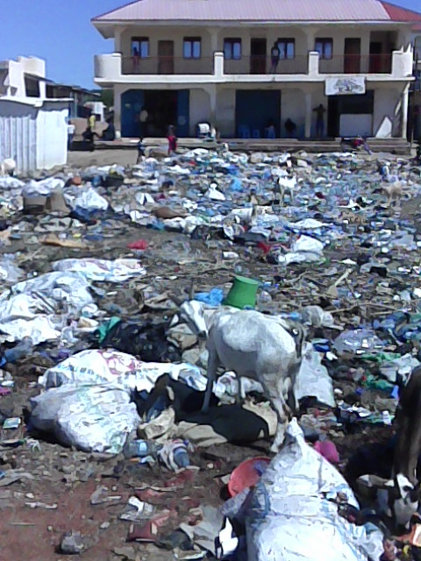

**DECLARATION**

**Researcher Declaration**

This research study project is my original work conducted between 18th. April 2019 to 27th. May 2019 for the intended purpose of the award of post graduate Diploma in Water Sanitation and Hygiene by the African Institute for Project Management Studies. It has not been presented to any other institution or body. No part of this research should be reproduced without my consent or that of the Africa Institute for Project Management Studies.

**Name: Isaac Wuddu Bullen Signature: IW Date: 29th. May 2019**

**Declaration of the Supervisor/Lecturer**

This research project has been submitted for defense with my approval as the Africa Institute for Project Management Studies Supervisor.

**Name: _____________________Signature: _________________ Date____________**

**Lecturer Supervising**

**For and on behalf of the Africa Institute for Project Management Studies.**

**Name: _____________________Signature: _________________ Date____________**

**TABLE OF CONTENTS: Page**

Declaration …………………………………………………………………………………………………….. 1

Dedication ………………………………………………………………….………………………………….. 4

Abbreviation and acrimony ……………………………………………………………………………. 5

**CHAPTER ONE**

Introduction …………………………………………………………………………………………………….. 5

Background ……………………………………………………………………………………………………… 7

Preface …………………………………………………………………………………………………………….. 7

Country sanitation situation …………………………………………………………………………….. 7

Statement of the problem ……………………………………………………………………………….. 9

**CHAPTER TWO**

Research objectives …………………………………………………………………………………………. 11

Overall objective ………………………………………………………………………………………………. 11

Specific objective ………………………………………………………………………………………………. 11

Significance of the study ……………………………………………………………………………………. 12

Limitations ………………………………………………………………………………………………………… 12

Scope of research study …………………………………………………………………………………….. 13

**CHAPTER THREE**

Research methodology ……………………………………………………………………………………… 13

Research design ………………………………………………………………………………………………… 13

Study area …………………………………………………………………………………………………………. 14

Sampling method ………………………………………………………………………………………………. 15

Sampling size ……………………………………………………………………………………………………… 15

Data collection method ……………………………………………………………………………………… 15

Data quality assurance …………………………………………………………………..………………….. 15

Data analysis ……………………………………………………………………………………………………… 16

Ethical considerations ……………………………………………………………………………………….. 16

Facilitating factors …………………………………………………………………………………………….. 16

Methodology …………………………………………………………………………………………………….. 16

**CHAPTER FOUR**

Data analysis and interpretation ………………………………………………………………………… 17

Profile of inhabitants of greater Joppa Boma ……………………………………………………… 17

Presentation of statistics and data ……………………………………………………………………… 18

**CHAPTER FIVE**

Summary of findings ………………………………………………………………………………………….. 28

Conclusions ………………………………………………………………………………………………………… 34

Recommendations ……………………………………………………………………………………………… 35

Activities for intervention ………………………………………………………………………………….. 39

References …………………………………………………………………………………………………………. 41

Metrics of important study variables …………………………………………………………………. 42

**DEDICATION**

I dedicate this research paper to my family for their great understanding as I spent much time away working, studying, researching and collecting data. I recognize and thank them for the sacrifice they made in allowing me to divert family resource at the expense prioritizing this studies.

**ACKNOWLEDGEMENT**

I would like to thank God for granting me good health throughout the period I have been working, studying and researching. My work and studies were never interrupted in any form. I want to appreciate my direct supervisor Juliette De Gaultier for being very understanding and allowing me to conduct and collect data as I attend to my daily duties. I would like to appreciate the support and encouragement from my manager Mr. Alfonso Cuevas for his continuous encouragement and support. I also acknowledge the support of my working colleagues for their critical discussions, for asking some of the questions and supporting with actual data collection.

In a special way I would like to appreciate continuous step-by-step guidance by my academic supervisor whom without him, it couldn’t have been possible for me to come up with this comprehensive document.

Lastly, I would like to sincerely thank African Institute for management studies for granting me the opportunity to enroll for the postgraduate diploma studies in WASH that in many ways will enable me to effectively contribute to solving WASH issues in my country the Republic of South Sudan.

**ABBREVIATION/ACRONOMY**

B/H……………………………………………….................................................................. Borehole.

CBHPM ……………………………………….……..….…… Community Base Hand Pump Mechanics.

CLTS …………….............................................................. Community Lead Total Sanitation

CPA ……………………………………………………….……………… Comprehensive Peace Agreement

CWMC ……….…………………………………………. Community Water Management Committee

HH…………………..................................…………………………………………………………….Household

CHP…………………………………………….………………………………… Community Hygiene Promoter

INGOs…………………………………………………. International Non-Governmental Organizations

MHPP …………………………………………………………. ministry of housing and physical planning

MOH ……………………………………………………………………………..………………… ministry of health

MWRI ………………………………………………………….. Ministry of water resource and irrigation

NCP …………………………………………………………………………..……………. National congress party

JCC …………………………………………………….………………………………………..…... Juba City Council

NNGOs ……………………………….…………………… National Non-Governmental Organizations

OD ………………………………………………………….……………..…………….……………Open Defecation

O + M ………………………………………………………………………………. Operations & Maintenance

PHAST ………………………….…..….…….. Participatory Hygiene and sanitation transformation

RSS ……………..………………………………………………….………………..…… Republic of South Sudan

SPLA/M ……………………………………………………… Sudan people liberation army/ movement

SSP…………………………………………………………………………………..…….… South Sudanese Pound

SHC ……………..……………………………………………………….…………………….. School hygiene clubs

UNICEF ………………………..………………..………….………………….. United Nations Children Fund

VIP ………………………………………………………………………………………… ventilated improved pits

WHO ………………………………………………………………….………………… world health organization

WASH …………………………………..…………………………….………… Water Sanitation And Hygiene

**CHAPTER ONE**

**RESEARCH STUDY PRELIMINARIES**

1. **INTRODUCTION**

South Sudan attained her independence on 9th. July 2011 and became an independent state from the Sudan after 21 years of revolutionary civil war. The independence ended African’s longest ever fought civil war. The Comprehensive Peace Agreement (CPA) signed in Naivasha (Kenya) in 2005 between the Sudan People’s Liberation Movement and Army (SPLM/A) and National congress party (NCP) ended the conflict paving way for a referendum in 2011 after 6 years of transition period. The south Sudanese overwhelmingly voted for independence from north Sudan. By mid-December 2013, disagreement arose between the Sudan people’s Liberation Movement (SPLM) leadership that resulted in 6 years of senseless war among the south Sudanese that killed more than 400,000 people and displaced more than 2 million people within the country and into the neighbouring countries. Gains from WASH infrastructure investments and services provided by International NGOs and NNGOs were reverse. People’s livelihood, attention and behaviours change from development to survival.

The impact of change resulted in dwindling of knowledge and awareness on the effect of open defecation, poor sanitation, poor solid waste management and poor hygiene practices that contributes to high mortality and morbidity rates. Faeco-oral diseases especially amongst children under five years old doubled. Poor educational performance in lower educational institutions. Adolescent girls dropping out of school due to poor or lack of sanitation and menstrual hygiene management facilities and consumables increased. Wide practice of open defecation, poor sanitation, solid waste management and hygiene practices contributed to persistent poverty among the peri-urban and slum dwellers because their little hard-earned money is spent on medically preventable diseases.

1. **BACKGROUND**

This research paper is on water sanitation and hygiene situation covering peri-urban and slum dwellers of greater Joppa Boma comprising of about 850 households divided into demarcated block 6 zone and un-demarcated slum areas of Joppa Silk and Joppa Pereng. The greater Joppa Boma is located on the North western part of Luri County annexed to Juba City Council (JCC) where the seat of the government of the Republic of South Sudan is located. This research paper focuses on the sanitation and solid waste management practices of the inhabitants of greater Joppa Boma. Even though greater Joppa Boma is a peri-urban and slum area in Juba City Council, it was a perfect choice because of the diversity of its inhabitants and the topographical set up of the area that is comparative to more than 60% of the total surface area of the republic of south Sudan.

1. **PREFACE**

This research paper introduces the reader to the general water sanitation and hygiene situation in the greater Joppa Boma. The paper then focuses on the sanitation and solid waste management of the inhabitants of the area, the prevalence of open defecation and its implication on the public health of not only the people of greater Joppa area but also its neighbourhood and visitors. The research paper summarizes the findings, practices of the people of greater Joppa and the problems affecting the people. The paper also high lights on the environmental setup of the area and the socio-economic issues that might have influence the prevalence of all negative practices of the people of greater Joppa. The research paper then concludes and recommends solutions and practicable action to be taken by any Non-Governmental Organization that would be willing to intervene in greater Joppa Boma.

**4- COUNTRY SANITATION SITUATION**

**4.1-** According to South Sudan national sanitation and hygiene strategy of 2011-2017,

a- Most communities in South Sudan do not use pit latrines because traditionally they are used to openly defecation in the bushes

b- Latrine coverage was 36%, with 11.4% having a hand-washing facility and of the available toilet facilities; only 1.5% was ventilated improved pit (VIP) latrines.

c- In communities that have overcome the traditional hurdle and are using latrines, lack of latrines is blame on lack of finances.

d- In some parts of most of the States, collapsing formations, and/or rocky grounds hampers Construction of pit latrines.

e- Apart from the small systems covering the Ministries complex and Hai Amarat in the capital city Juba, there are no sewage systems in place in the whole of South Sudan. Presently, the majority of citizens use various types of latrines with seepage pits or septic tanks.

f- The allocation of institutional responsibilities for urban and rural sanitation between Ministry of Water Resources and Irrigation (MWRI), Ministry of Housing and Physical Planning (MHPP) and Ministry of Health (MoH) and the City Council/County (Local Government) has not been clearly determined. The responsibilities still need to be clarified and ideally aligned with the respective organizations in charge of water supply, both at the policy and the operational levels.

g- The long decades of war have seen a decline in sanitation services, and current capacities require substantial strengthening. Emerging urban centres may soon require sewerage networks and the Sanitation Departments in the MHPP and in the States will start to put in place a mechanism for operating de-slugging facilities or equipment for emptying septic tanks.

H- Overall the level of access to appropriate sanitary facilities is estimated to be 14.6% and much lower in remote rural areas. In reality, most of these facilities are in very poor condition due to lack of maintenance.

1. The general level of hygiene awareness and of vectors relations to disease is very low. The incidence of waterborne and hygiene-deficiency diseases is wide spread. Sanitation achievements are still very modest in South Sudan as there was previously not enough emphasis placed on it, largely due to long period of civil war.
2. Concepts such as Community Led Total Sanitation (CLTS) need to be promoted alongside Incremental improvements in latrine design which are commensurate with household affordability. The focus will continue to be on household, environmental and institutional sanitation such as in public places, including schools, health facilities, markets and bus parks, provision of products and services for household latrine upgrading and equipment for sewage removal and disposal. Ministry of Water Resource and Irrigation (MWRI) will work more closely with Ministry of Health (MoH) and Ministry of General Education (MGE) before contracting institutional latrines at health centres and schools to ensure facilities are built where they are really needed and to avoid duplication. Unsustainable subsidies will be discouraged.

**4.2-** According to UNICEF 2018 country report, the sanitation situation in south Sudan is as follow:

a- Seventy one percent 71% of the population in South Sudan practice open defecation

b- Only 29 percent of the population use traditional and improved latrines or flush toilets

c- Out of the 29 percent population that use traditional, improved latrines and flush toilets, 55 percent are concentrated in the city, municipal councils and other small towns

d- Out of the 29 percent population that use latrines, only 17 percent of them has hand washing facilities

e- Apart from the Ministries and Hai Amarat in the capital city, there are no sewage system in the whole country

f- Most of the 20 percent population in the city, municipal councils or other towns use septic tanks.

g- The five year gruesome war have seen a decline in sanitation services, and current capacities require substantial strengthening

1. **Statement of the Problem**

Evidence shows that without water there is no good hygiene practices and that the less readily available water is, the less likely that good hygiene will be practiced at households and institutional levels. Maintaining water safe till times of use, Use of safe water for all household purposes and for personal hygiene contributes significantly to reduction of diarrheal related Illnesses.

Again evidence shows that when sanitation facilities are not clean, when sanitation facilities are not segregated between males and females, and that when sanitation facilities doesn’t provide privacy and when sanitation facilities are in locations that risks the personal safety of the user especially females at certain hours of the day, the facilities will not be acceptance and use.

Waste production and management by households where dumping or disposal places is limited or not available is increasingly becoming another threat to household and public health. Accumulated waste harbours contaminant pathogens, Accumulated solid waste also become a perfect place for reptiles, rats and cockroaches to breed increasing the risk of communicable diseases spreading to spread infecting more people. Decomposing waste also attracts flies that carry pathogens to contaminate water and food within households and also pollute the air.

Research has also shown the evidence on the importance of improper personal hygiene behaviour and in particular hand-washing with safe running water with soap or ash at all critical times in perpetuating the ingestion of pathogens that causes diarrhoea.

**CHAPTER TWO**

1. **RESEARCH OBJECTIVE** 
   1. **OVERALL OBJECTIVE**

The research study’s overall objective is to establish the Sanitation coverage and Waste management practices of the people of Greater Joppa, Availability of basic sanitation facilities and usage at households and environmental sanitation cleanliness

* 1. **Specific Objectives:**
* To establish the coverage of basic sanitation among the target population of greater Joppa.
* To ascertain the demand for use of basic sanitation among the target population.
* To determine community’s knowledge in linking good sanitation and waste management practices to the prevalence of diarrheal related Illnesses.

This research aims to establishing the status of water, sanitation and hygiene situation in greater Joppa Boma.

Water, sanitation and hygiene services demand and usage in every community is driven by the community’s knowledge that influence their good practices in utilizing the water sanitation and hygiene services provided.

* 1. **Significance of the Study**

The information collected from this research study will be useful in identifying and planning vital WASH needs of the communities in Greater Joppa. This study comprehensively investigate and establish the impacts of Environmental Sanitation activities in greater Joppa. The research paper recommend interventions that may guide local WASH authorities at County level, Municipal council, state ministry of rural water and sanitation, concerned NGOs, UN agencies to address WASH and Environmental Sanitation activities in one of the worst affected Peri-urban and slum areas around Juba City Council. The results are also meant to contribute to the formulation of future policies and strategies by different government authorities at all levels and other NGOs concerned with WASH activities and Environmental Sanitation. This research paper will also form a baseline for Non-Governmental Organization that would want to intervene in supporting the people of Greater Joppa in due future.

* 1. **Limitations**

There were few major constraints faced during the research study these included:

1. Lack of public transport system in and out of the area forcing most movement in and out on foot
2. Insecurity in the area perpetuated by organized and individual criminals due to lack of organized forces nearby.
3. Rigidity of some respondents who wanted money in exchange of information they were asked to provide.
4. Consultations with government officials on study mission to the area delayed the commencement of the research study.
   1. **Scope of research study**

The research study focused majorly on sanitation practices of the community of greater Joppa area. This include what contributes to open defecation and poor household waste management. However, other key sub-sectors like safe water supply and hygiene knowledge were also covered. This is because safe water availability facilitates the practice of good sanitation while hygiene knowledge influences personal behaviors of the people studied. The research study visited households in the residential areas and conducted transact walk in areas suspected to be open defecation fields and mini market in greater Joppa. The research study also trans-walk a high way bordering greater Joppa to the south to investigate presence of garbage deposited in the middle of the high way. The study investigated and analyzed how people dispose their faeces and provide recommendations as to how the community can stop open defecation.

**CHAPTER THREE**

1. **RESEARCH METHODOLOGY**
   1. **Research Design**

The researcher used design tool when conducting the study. Mostly closed ended questionnaire were used to obtain information concerning the current sanitation, waste management and hygiene practices of the targeted population investigated. Observation on availability of facilities and or indicators of practices was also use to enrich the information obtained from the respondents.

**Stage 1:** Comprises the development of household questionnaires, planning and identification of qualified enumerators from the neighbourhood to administer the questionnaire.

**Stage 2:** Consist of appraising of research tools. A one day orientation was conducted on study frame work, pretesting of research tools as well as ethics of community approach. Terms of reference (ToR) were shared on the study framework which exclaims the sampling process. Data collection tools were pre-tested by the enumerators to ensure all errors are cleared to avoid multiplying the chances of invalidating the information collected from the population and time covered to administer the questionnaire in a single household.

**Stage 3:** Comprises of field work where five (5) enumerators administered the questionnaires in five (5) working days. Each enumerator administer questionnaires to eight respondents a day covering 40 households. A total of 200 respondents were administered in 200 households randomly selected. Spatial and systematic sampling begins from the centre of the greater Joppa where sampling spread through 4 geographical directions.

**Stage 4:** Data Cleaning, Entry, Analysis and Reporting**:** This included data cleaning and entry. Comparative data analysis was conducted among the variables to compare the actual verses prevalence of negative sanitation and waste management practices within the population. Data from the field were analysis using the SPSS-Excel to quantify the information.

* 1. **Study Area**

Greater Joppa area stretches from north to the west of Juba city council. Joppa area is characterized by flat fertile arable lands with black cotton soil compared to the southern part of Juba city council which is mountainous with deep draining patterns.

Most of the population of greater Joppa area mainly defecate in the open. Despite blocks 6 being demarcated area with people owning their plots only Joppa Pereng and Joppa silk are the areas that awaits demarcation.

The greater Joppa area has a population of 5100 people accommodated in 850 households divided into block 6, Joppa Pereng and Joppa silk. Block 6 is officially demarcated areas while Joppa Pereng and Silk still awaiting demarcation into class four plots measuring 300 square meters each.

* 1. **Sampling method**

For the purpose of the study, questionnaires and focal group discussion with resource persons were used to collect the data. The questionnaires were structured in such a way that it obtained both qualitative and quantitative data.

* 1. **Sample size**

A sample is a representative of population. The sampling technique adopted was stratified random sampling method. It was used since it is viewed to be free from biasness of population; it considered all levels of population. A sample size of 200 respondents was drawn representing almost 22% of the target households. The researcher used the following formula for the sample size n:

n = N*X / (X + N – 1),

where, X = Zα/22 ­*p*(1-p) / MOE2, and Zα/2 is the critical value of the Normal distribution at α/2 (e.g. for a confidence level of 95%, α is 0.05 and the critical value is 1.96), MOE is the margin of error, p is the sample proportion, and N is the population size.

* 1. **Data collection method and tool**

This is a list of mainly closed ended questions asking a number of persons seeking their responses that can be tabulated and treated statistically. It is a form for securing answers to questions from respondents. The researcher used both structured and unstructured questionnaire which have both structured and semi-structured questions. There was a pre-determined question whereby respondents were asked with the questionnaire and are given a chance to answer. The types of questions used were both open and closed ended questions. Closed ended questions were used to ensure that the given answers were relevant. The researcher phrased questions clearly in order to make dimensions along which response were analyzed. In open-ended questions, space were provided for the respondent, thus giving him/her freedom to express their feeling. Observation during the conduct of the questionnaires were also recorded to enrich the data collected.

* 1. **Data quality assurance**

The researcher selected some enumerators from nearby Boma who were then oriented on the questionnaires for batter understanding to minimize margins of errors or interpretations of the respondent’s answers. The questionnaire were then tested to determine time taken to answer all questions. The enumerators were then commissioned to administer the questionnaire and record their observations.

Participatory Group Discussion (PGD) were conducted by the researcher involving the chief of Joppa Pereng and Silk and some elders, Women leaders and Government representative from the County.

* 1. **Data Analysis**

This included data cleaning, entry and Comparative data analysis was conducted among the variables to compare the actual verses prevalence within the targeted population. Data from the field were then analysis by the researcher using the SPSS-Excel to quantify the information collected.

* 1. **Ethnical Consideration**

The enumerators were selected from both males and females. This is to allow female enumerators to ask fellow females respondents some questions that are culturally deemed sensitive for persons of the opposite sex to ask. This encourages openness and sincerity in drawing answers from respondents. Ethics of community approach by the enumerators was considered paramount to freely obtain information from the respondents.

* 1. **Facilitating factors**

The major factor that contributed to the success of this research study was the cooperation of the community studied. The commitment exerted during data collection led to the timely completion of the report. Not only limited to these, the other factor was the nature of the sample size, the respondents were so willing to share the devastating experiences that they have gone through. They were very frank and open while discussing issues relating to the main subject of the research study and gave required views with likely improvement needed.

* 1. **Methodology and Information Source**

Field visits to greater Joppa where questionnaire were conducted, participatory group discussions with the chief and community elders, women and youth from the indigenous, returnees and IDPs settlers was conducted. Key Information Interview was conducted with Luri county WASH Director. The WASH officials in the State give detailed challenges and gaps that need attention in water, sanitation and hygiene in Juba city Council and its peri-urban and slum areas including Greater Joppa.

**CHAPTER FOUR**

1. **DATA ANALYSIS AND INTERPRETATION**
   1. **PROFILE OF INHABITANTS OF GREATER JOPPA BOMA**

This study research paper targets the population residing in Greater Joppa represented in 850 households. An average household size in greater Joppa is 6 people per household. Out of the 64 tribes in South Sudan, Greater Joppa Boma boost of inhabiting almost 20 different tribes. Greater Joppa inhabitants are mainly working within Juba city Council as laborers, domestic workers, porters and daily casuals’ workers. The inhabitants are mainly the unskilled work force with no education, unskilled or lower secondary education levels. Even though some of greater Joppa area residents were push from Gudele and other demarcated areas within Juba City Council, most of them originally fled from their villages across South Sudan escaping the senseless war being impose on the South Sudanese by its political leaders. Almost all of greater Joppa inhabitants are Christians and animist believers.

Greater Joppa Boma stretches from north to the west of Juba city council. Greater Joppa Boma is characterized by flat fertile arable lands with black cotton soil compared to the southern part of Juba city council which is mountainous with deep draining patterns. The greater Joppa Boma has a population of 5100 people accommodated in 850 households divided into blocks 6, Joppa Pereng and Joppa silk. Blocks 6 is officially demarcated area while Joppa Pereng and Joppa Silk still awaits demarcation into class four plots measuring 300 square meters each.

* 1. **Presentation of statistics and data:**

**4.2.1- Respondents Profile**

The population of greater Joppa consist of 55.5% youth between the age of 18 and 40 years with only 32.5% of the population at the age above 40 years. One hundred and forty eight (74%) of the respondents were females with 124 (62%) of them being house wives at the reproductive age between 18 and 40 years.

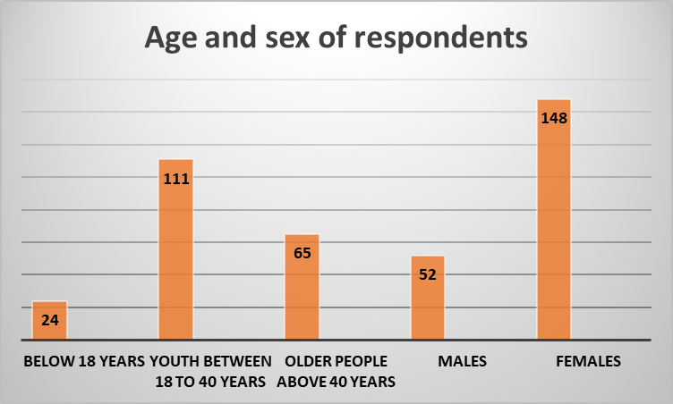

**4.2.2 Education levels of studied population**

The levels of education of the population of greater Joppa Boma is very alarming with 40.5% of the respondents who have not attended any formal education and only 29.5% who attended some primary education and 22% who attended secondary education. With only one primary school in the whole area, this high rate of illiteracy coupling with lack of schools and trained teachers will aggravate the illiteracy rate further within the population of greater Joppa area. The illiteracy rate in greater Joppa might have contributed to low knowledge on good sanitation and hygiene practices that breaks the cycle of disease transmission.

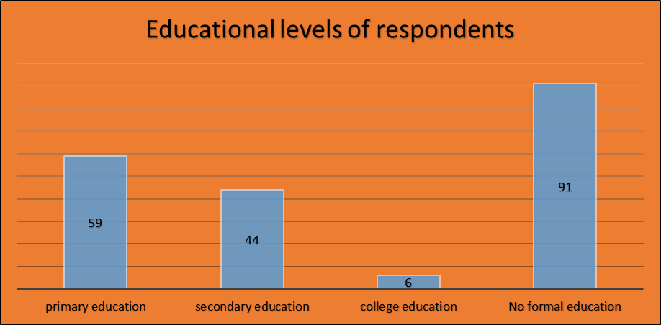

**4.2.3 Respondent marital status**

Ten point Five percent (10.5%) and Five point Five percent (5.5%) of the respondents were single family heads. With an average family size of 6 people, the population of greater Joppa is set to grow at an alarming rate further aggravating the undesired sanitation and waste management situation in the area which might result in an outbreak of disease leading in to an emergency situation. The sixteen percentage (16%) of widows and widowers might reflect the impact of the crisis in the country on security perspective and also on economic income for the family sustenance and basic services provision. This can be link to the poverty rate observed among the studied population.

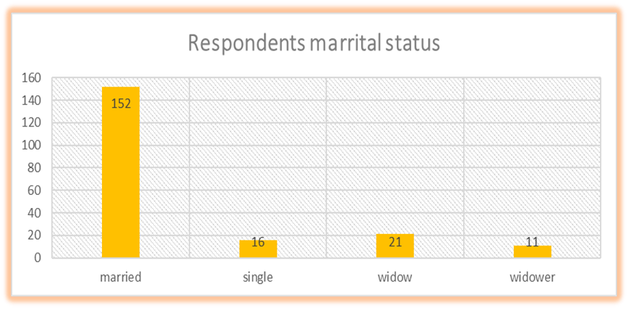

**4.2.4 Respondents resident status**

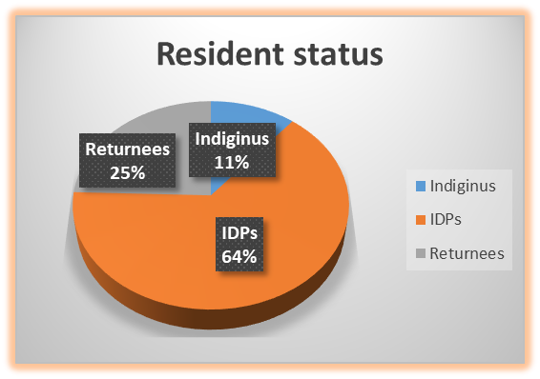One hundred twenty Nine (129) of the respondents were Internally Displaced people (IDPs) who ran to juba escaping the civil war that engulfed the country in mid-December 2013 while 49 of the respondents were returnees from Sudan after South Sudan succeeded and attained independency in July 2011. Only Twenty Two (22) of the respondents were the indigenous settlers from the Bari tribe.

* 1. **SANITATION OBSERVATION AND PRACTICE WITHIN HOUSEHOLDS STUDIED**

**4.3.1- Sanitation observation in studied households**

The sanitation situation and waste management in the households studied in Greater Joppa Boma is not only undesirable but neglected. Sanitation at household levels is very poor with human feaces seen in forty Eight percent (48%) of the household compounds. One hundred thirty three (133) of the households representing (66.5%) do not have latrines while rubbish seen scattered in Sixty Six (66) household compounds representing 33%. Children with Skin and eye infections were seen in sixty nine (69) households representing 34.5% of the total households sampled. Over fifty three (53%) of the households respondents observed did not have bathing shelters indicating that they bath at night behind their houses or going for several days without bathing.

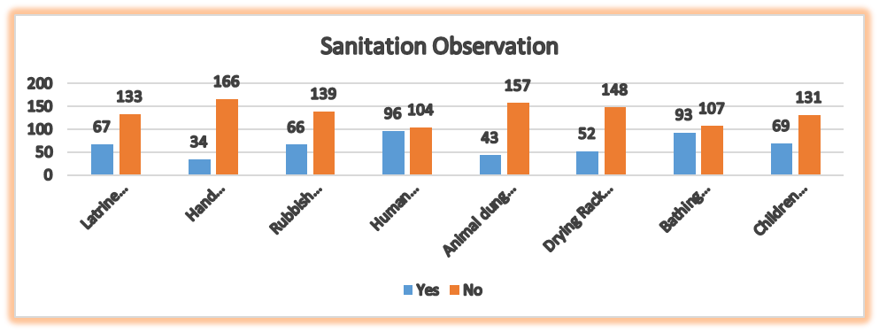

**4.3.2- Latrine coverage and usage**

Fifty Seven percent (57%) of the household samples admitted to not having latrine while Eighty Eight point Five percent (88.5%) say they had latrines but collapsed. Thirty Five point five percent (35.5%) of the Forty three percent (43%) who admitted to having latrines do not use their latrines always. Fifty point five percent (50.5%) of the respondents claimed to have used latrine the last time they defecate. Over Eighty eight percent (88%) of the respondent households had latrines at some time but collapsed due to floods or poor construction. All the collapsing latrines were attributed to the loose soil formation that curves in during rainy seasons. Over Eighty percent (80%) of the latrines were located in the demarcated part of Joppa area. Sixty percent (60%) of the latrines are owned by family heads who have attended some formal education and resides in improved residence reflecting batter income, their levels of formal education, exposure to and or knowledge of WASH communicable diseases attached to those households.

**4.3.3- Willingness to use latrine**

Seventy four percent (74%) of the respondent says using a latrine is important and the same percentage is willing to share family latrine with people from the opposite sex as long as every user who uses the latrine leaves it clean for the next person to use. Over sixty eight percent (68.5%) of the respondents says children should have their own latrines because they drop out making latrines dirty to be use by adults. Eighty eight percent (88%) of the respondents are not willing to share latrines with their parents In-laws who stays with them at home or during the time their in-laws come to visits them or they themselves go to visit their in-laws. Eighty Nine percent (89%) of the respondents are not willing to use public (communal) latrine because

1. Public latrines are always not clean
2. Fear of contracting communicable diseases at the time of using public latrine
3. Fear of being seen entering or coming out of the latrine by strangers.

The reasons given might have been attributed to previous experiences of assumptions that public latrines are not kept tidy for user. Other reason might be that public latrines charge a fee for single time use that the respondents were not willing to pay because they can’t afford to do so.

**4.3.4- Knowledge on importance of latrines usage**

Knowledge on the importance of latrine usage among the population is very low and not rooted. This might be attributed to low knowledge on transmission of communicable diseases. Forty seven percent (47%) of the respondents seems to be willing to use latrines just because it provides privacy compared to 8.5% who says latrine usage deprives flies and other animals from carrying germs to contaminate food and water in their houses. Even these thinking was not rooted to developed into believe and hence it is practice. Knowledge on using latrines to improve health status and protect the environmental to avoid contamination of water sources among the respondents was very low compared to provision of dignity and protection that seems to be the primary willingness to use latrines among the population. The low prioritization on latrine construction and usage might be attributed to the low levels of general awareness on the dangers of open defecation, low prioritization and investment of funds to construct latrines and the hard economic situation that has hit the country as a result of the senseless war.

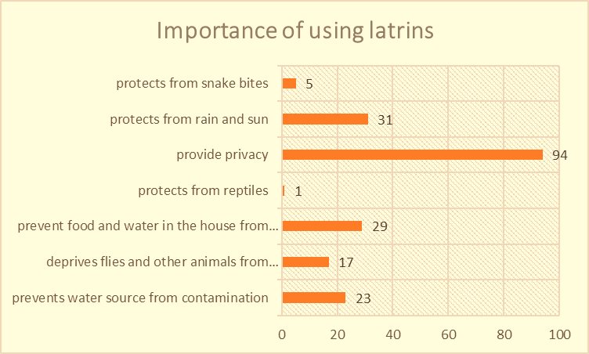

**4.3.5- Limitations from latrine usage**

Thirty eight percent (38%) of the respondent asked says they don’t use latrine because of unavailability. Over twenty three percent (23.5%) of the respondents prefer to defecate in open either in the bush or along the stream when they go to bath or to collects water during the rainy season. This might be attributed to the low levels of general awareness on the dangers of open defecation, the lack of latrines, vast lands for defecations. Only seven percent (7%) of the respondents says they defecate when they are in the field or working places where latrines are available. Over fifteen percent (15.5%) of the respondents say they don’t use latrine because the latrines to be use are being shared with other people. This might be attributed to their belief that influence their decision not to use shared latrines.

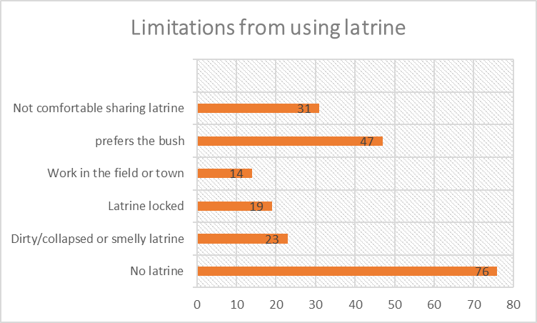

**4.3.6- Handling of children feaces**

Handling of children feaces is very alarming by households in greater Joppa Boma. Children feaces are handled in a way that portrays it as not harmful and dangerous as adult’s feaces by most of the respondents. Only sixteen percent (16%) of the respondents disposes their children feaces in a pit latrine while five point five percent (5.5%) burry their children feaces. Thirty point five percent (30.5%) throw the feaces of their children to any nearby open places while twenty five point five percent (25.5%) throw the feaces of their children in to household or communal rubbish pit. The practices of disposing children feaces in an open place within the households can definitely be equivalent to open defecation by older children and adults. This is because children feaces carry the same pathogens as adults and poses the same danger to all inhabitants within the neighbourhood.

**4.3.7- Household waste generation**

Most of the household waste generated in greater Joppa Boma are organic waste that is degradable or can be compost to generate soil fertalizing material that can improve vegetable production.

Over fourty four percent (43.5%) of the waste generated by households is from vegetable peelings with additional thirteen three percent (13%) generated from food remnants, papers, cloths and plant leaves. This means more than fifty six percent (56.5%) of the waste generated in greater Joppa can be compost and reuse. Thirty seven percent (37%) of the waste generated by households in greater Joppa Boma are from plastics and rubber materials which ends mostly along the road side and other open places within the Boma.

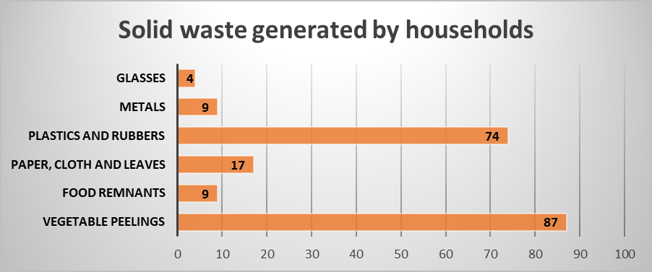

**4.3.8- Household waste disposal**

Household waste management in greater Joppa Boma is not desirable indeed. Improper disposal of liquid and solid waste couples with negligent disposal of children feaces and open defecation practices in greater Joppa Boma aggravates the health risks the whole population is exposed to. There is no designated place by local authorities for dumping household waste. Every household disposes its waste in any place convenient to them not mining the public health of the inhabitants of greater Joppa Boma.

Forty percent (42%) of the respondents says they dump their household waste in any open place while twenty eight point five percent (28.5%) dump their household waste along the road side. Only sixteen point five percent (16.5%) of the respondent says they dump their household waste in family rubbish pit and four point five percent (4.5%) dump their household waste in a communal rubbish pit. Eighty two percent (82%) of the respondents do not in any way pay for the disposal of their household waste compared to only eighteen percent (18%) who pays some individuals for disposing their household waste either to any open space or along the road side since there is no council dumping site.

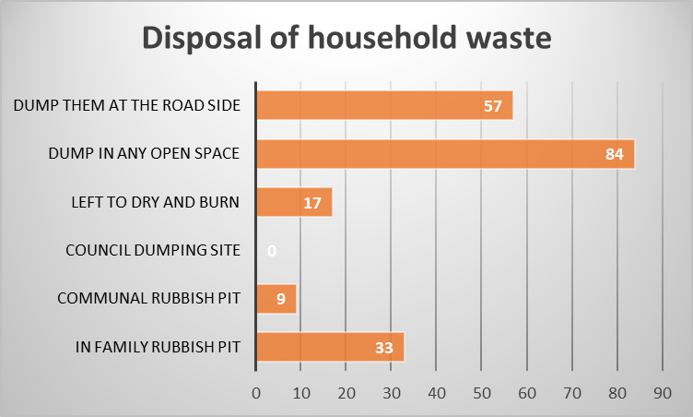

**4.3.9- Hand washing habits**

Hand washing with soap at critical times was one of the paramount variables in this study survey considered to be effective in breaking the cycle of disease transmission. Seventy six percent (76%) of the respondents do not have hand washing containers with soap or ash near it. Of the twenty four percent (24%) respondents who says they have hand washing containers, observation by the enumerators suggests that only 9.5% are actually being used.

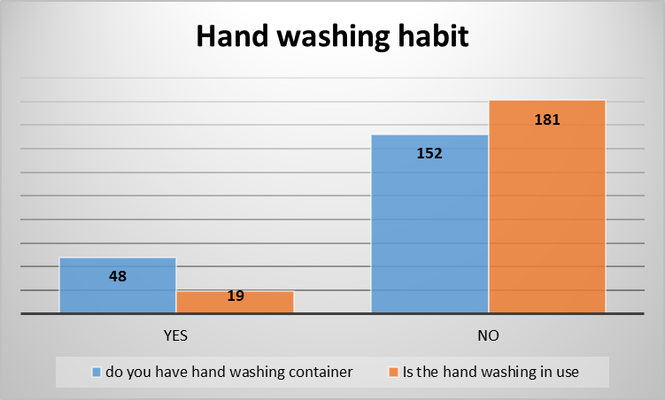

**4.3.10- When do you usually wash hands**

Even though Hand washing practice seems to be rooted within the population surveyed, hand washing at critical times is not practiced in a manner that eliminates and prevents the ingestion of pathogens. Diarrhoea is a major killer among infants which can be prevented by improving sanitation and personal hygiene. As indicated in the above paragraph on hand washing habits, washing hands with only safe water or in a communal bowel doesn’t prevent the ingestion of disease causing pathogens. The critical times that breaks the cycle of disease transmission were not among critical times mentioned by the respondents. Over ninety four percent ((94.5%) of the respondents wash hands before eating while only twenty seven percent (27%) wash hands before preparing and serving food. This implies a very high possibility of food contamination with dirty hands before being picked and eaten with clean hands. Sixty four percent (64%) of the respondents do not wash hands after defecation while only ten point five percent (10.5%) wash hands before handling drinking water. The percentages of hand washing in 2 most critical times of after visiting or defecating and before breast feeding or feeding a child poses greater risk of ingestion of disease causing pathogens by both adults and infants.

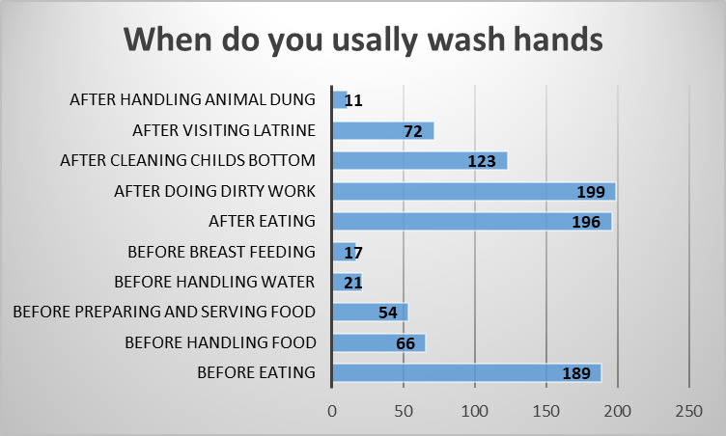

**4.3.11- What do you use for washing hands?**

Hand washing among the population studied seems to be rooted with over eighty percent of the population washing hands with safe or any water with soap or without. This implies that proper hand washing with safe running water and soap or ash to remove all pathogens in somebody’ hand is not followed. Washing one hand which is widely practice in South Sudan even though with running water and soap or ash doesn’t remove pathogens from somebody’s hand. Again as mentioned earlier, communal hand washing in a bowel actually spreads disease causing pathogens from one person to another before they start eating. Out of the studied population, only forty nine percent (49%) of the respondents wash hands with safe running water and soap. Despite over eighty eight percent (88.5%) of the respondents saying that they wash hands with any water without soap, only three percent wash their hands with any available water with ash. This hand washing practice doesn’t remove pathogens from their hands hence ingestion is inevitable. Among the population studied, knowledge of washing hands with running water and ash to remove disease causing pathogens from somebody’s hands is almost lacking. The population seems not to know that in the absence of soap for hand washing, using safe running water with ash can remove disease causing pathogens from their hands that will minimize ingestion. Good hand washing practices is always linked to the levels of understanding of the individual and the ability to relate it to WASH communicable diseases and poverty as a result of spending money on preventable diseases.

**CHAPTER FIVE**

1. **SUMMARY OF FINDINGS, CONCLUSIONS AND RECOMMENDATIONS** 
   1. **SUMMARY OF FINDINGS:** 
      1. The impact of the crises that erupted in the country in mid-December 2013 has greatly impacted on the population studied in greater Joppa Boma. Poverty rose to unprecedented levels compared to the peaceful post year after independence and in comparison to other slums areas around Juba City Council. Household’s main means of livelihoods cannot be documented because everybody’s focus is on survival by all available mean including those means that are associated with crimes and banditry. Support from relatives and begging constitute major survival means of the households. Corruption at all government levels is visible in form of lack of basic services. No schools, health center and even a police post to maintain law and order in greater Joppa Boma are available. Joppa Pereng and Silk remain not demarcated since the populations were push there in 2012 after the closure of the returnee’s camp in Kapuri area. Greater Joppa Boma can be describe as an area without Government, insecure, ignored and engulfed with poverty.
      2. More than sixty five percent (65%) of the population of greater Joppa Boma are young people that could form a big working force that could foster development, increase incomes and improve livelihoods including the sanitation and waste management practices of the population.
      3. Fifty five percent (55%) of the population in greater Joppa Boma are illiterate. There is only one private primary school run by a church that is ill funded and one kinder garden (Nursery) that mainly keep children in a compound to play than to learn and prepare them to join primary school. This alarming rate of illiteracy couple with poverty have greatly contributed to the undesired sanitation and waste management condition among the population of greater Joppa Boma.
      4. Seventy Six percent (76%) of the respondents in the study survey were married females or males. This indicates that the more than 75% of the respondents are within child bearing age. With an average family size of 6 people, the population of greater Joppa is set to grow at an alarming rate further aggravating the undesired sanitation and waste management situation in the area which might result in an outbreak of disease leading to an emergency situation.
      5. Sixty four percent (64%) of the population studied are Internally Displaced Persons (IDP) who resides in the section not demarcated in Joppa Pereng and Silk. Lack of land ownership couple with unsecure job opportunities for households to settle, earn a decent living and start planning long term development including latrine construction and use might have contributed to the undesired sanitation and waste management practices of the people in greater Joppa Boma.
      6. The sanitation and waste management in the households studied in greater Joppa Boma is not only undesirable but neglected. One hundred thirteen (113) respondents representing 55% of the household observed didn’t have their own latrines. This means that they practice open defecation.

The presence of human feaces in the compounds of 96 respondents representing 48% households further indicates that improper disposal of human excreta is not considered to be dangerous or even associated with the spread of WASH related diseases within the household or the community at large.

Children with skin diseases and eye infections were seen in families of 96 respondents representing 48% of households studied. This indicates the poor personal hygiene practices and neglect by parents to hygienically care for their infants.

* + 1. Fifty seven percent (57%) of the household’s samples admitted to not having latrines. This indicates that they defecate in the open or share latrines with those household that has latrines.

Eighty eight percent (88%) of the households say they had latrines at some time but some of them collapsed. This is a clear indicator that most of the households had attempted to construct latrines but collapsed due to loose soil formation that curves in during rainy season even with the slightest floods. Poor construction designs and unaffordable quality materials also have contributed to latrines collapsing. This conditions frustrates households not to construct latrines fearing same scenario after wasting time, energy and even investing little cash to put up a family latrine.

* + 1. Sixty percent (60%) of the latrines are owned by family heads who have attended some formal education and resides in improved residence reflecting batter income, their levels of formal education, exposure to and or knowledge of WASH communicable diseases attached to those households.
    2. Seventy four percent (74%) of the respondent says using a latrine is important. This believe however is not rooted to develop into consciousness and practice that will influence attitudes that pushes people to consider investing in latrine construction and use as important as they invest in constructing living houses and cooking kitchen.
    3. Over sixty eight percent (68.5%) of the respondents says children should have their own latrines because they drop out making latrines dirty to be use by adults. This seems to be the strongest reason why latrines are lock and children are allowed to defecate in the open and also as evident in children feaces being seen in families of 96 respondents.
    4. Eighty eight percent (88%) of the respondents are not willing to share latrines with their parents In-laws who stays with them at home or during the time their in-laws come to visits them or they themselves go to visit their in-laws. This unwillingness to share latrines with in-laws is attributed to traditional beliefs and taboos that are associated bringing bad lack to the married couples. Other traditional believe is that man’s feaces must be seen by the parents to determine whether he is being fed well by the wife or not. This believes and taboos definitely encourages open defecation by those who belief and practice their belief.
    5. Eighty Nine percent (89%) of the respondents are not willing to use public (communal) latrine because Public latrines are always perceived not to be clean, Fear of contracting communicable diseases at the time of using public latrine and Fear of being seen entering or coming out of the latrine by strangers. These reasoning must have been attributed to previous experiences or assumptions that public latrines are not kept tidy for user. Other reason might be that public latrines charge a fee for single time use that the respondents were not willing to pay because they can’t afford to do so.
    6. Forty seven percent (47%) of the respondents seems to be willing to use latrines just because it provides privacy and another eighteen percent (18.5%) are willing to use latrine because it protects from rain, sun and reptiles. Knowledge of the above combined (55%) population on the importance of using a latrine to improve health status and protect the environmental to avoid contamination of water sources or food is very low. General knowledge and awareness on the dangers of open defecation relating it to WASH communicable diseases and its transmission among the population is very low. These low knowledge and awareness can also impact negatively on their willingness to invest on latrine construction and usage given the hard economic situation that has hit the country as a result of the senseless war and lack of proper income.
    7. Over seventy three percent (73%) of the respondents studied in greater Joppa Boma seems not to know that children feaces are as dangerous as adult feaces. Handling of children feaces is very alarming by households in greater Joppa Boma. Children feaces are left in the open either within the compound (25.5%), thrown into any open space (30.5%) and thrown into a rubbish pit (17.5%). Only sixteen percent (16%) of the respondents disposes their children feaces in a pit latrine while five point five percent (5.5%) burry their children feaces. The practices of disposing children feaces in an open place within the households or neighbourhood can definitely be equivalent to open defecation by older children and adults. This is because children feaces carry the same pathogens as adults and poses the same danger to all inhabitants within the neighbourhood.
    8. Forty percent (40%) of the respondents says they dump their household waste in any open place while fifty three point five percent (53.5%) dump their household waste along the road side. Eighty two percent (82%) of the respondents do not in any way pay for the disposal of their household waste compared to only eighteen percent (18%) who pays some individuals for disposing their household waste either to any open space or along the road side since there is no council dumping site.
    9. Hand washing with soap at critical times was not one of the paramount variables in this study survey but was considered to be effective in breaking the cycle of disease transmission. Seventy six percent (76%) of the respondents do not have hand washing containers with soap or ash near their latrines. Adapting handwashing as a habit with clean running water and soap or ash at all the critical times is the most effective and inexpensive way to prevent swallowing germs that cause diarrhea and other Illnesses could save be treated with medicines or vaccine.
    10. Sixty four percent (64%) of the respondents do not wash hands after defecation while only ten point five percent (10.5%) wash hands before handling drinking water. scientific research and found that hand washing contributes to reducing diarrheal and other communicable diseases by almost 50%.
    11. Out of the studied population, only forty nine percent (49%) of the respondents wash hands with safe running water and soap. Despite that hand washing practice among the population studied seems to be rooted with over eighty percent (80%) of the population washing hands with safe or any water with soap or without, this implies that proper hand washing with safe running water and soap or ash to remove all pathogens in somebody’ hand to prevent ingestion of disease causing pathogens is not followed.
  1. **CONCLUSIONS:**
     1. The study research concludes that the prevailing insecurity in the country has greatly impacted negatively on the lives of the people of greater Joppa Boma. Decent means of people’s livelihood have been disrupted and knowledge on good sanitation and hygiene practices have been reversed.
     2. Unsecure employment and limited income generating activities has aggravated the poverty levels among the population studied. This has greatly impacted on their ability to invest in their personal and family wellbeing.
     3. General knowledge and understanding of WASH communicable diseases and its routes of transmission is very low among the studied population.
     4. Dangers of open defecation, proper handling and disposal of children feaces among the studied population is very low. This poses a great danger that might result in an outbreak of diseases.
     5. The population studied needs to be supported with materials and technical advices to be able to construct and use household latrines.
     6. The population studied needs to adapt and practice hand washing with safe running water and soap or ash at all critical times to reduce chances of ingesting pathogens that cause disease.
     7. There is only one hand pump borehole serving the population in Joppa Pereng and Silk estimated at over 3000 people. Scarcity of water from safe sources and the expensive water being sold by the water tankers have contributed to poor hygiene practices in Joppa Boma.
  2. **RECOMMENDATIONS:** 
     1. This research study foresees that the journey to achieve sustainable meaningful WASH benefits in Greater Joppa Boma is very long. It needs efforts to normalize the current security situation and crate sustainable jobs that can enable the people of greater Joppa Boma to earn decent livelihoods that they can embark on rebuilding their lives and propel towards development.

* + 1. The research study recommends that International Non-Governmental Organizations (INGOs) intervene and invest in greater Joppa Boma and that the WASH Investment be of an emergency context needing to be responded through the direct provision of live serving interventions. This approach can gradually then be shift to recovery when the situation changes and plans for development that incorporates clear exit strategies put in place. This implies that any meaningful intervention in greater Joppa Boma has to be a long term programming in order to produce acceptable results that transforms the lives of the people.
    2. To improve the sanitation situation in greater Joppa Boma, INGO willing to intervene has to adapt the Participatory Hygiene And Sanitation Transformation **(PHAST)** methodology that subsidies individual efforts to construct and use latrines. This is because the poverty levels are high and the soil texture requires materials that are actually not affordable by majority if not all of the households. Adoption of the Community Lead Total Sanitation CLTS that should have been ideal to adopt will not work because of the above reason.

* + 1. For a sustainable programing, any INGO needs to invest in sensitizing and educating the population on WASH Communicable diseases and its routes of transmission. This will necessitate selection and training of community hygiene promoters from within the community who will then be equip with Information, Education and Communication (IEC) materials to be able to disseminate hygiene messages through house-house visit and campaigns. The program should be focus on disseminating the six (6) key sanitation and hygiene messages: 1- Human excreta disposal 2- Environmental sanitation 3- personal hygiene 4- safe water and food handling 5- safe water chain 6- hand washing at all critical times. This can be achieve through adaption of mass communication network focusing on educating and crating awareness on the dangers of open defecation and on Oro-faecal transmission of diseases. This can be channeled through institutions such as schools, Churches, Public places; health service delivery points and drama.
    2. Selection and training of efficient and effective PHAST facilitators and sanitation councilors from within the community to train the community on the PHAST methodology and to technically support individual households in excavation, covering and construction of the latrine superstructure. This will empower the community members with knowledge that they will be able to sustainably continue building latrine that will withstand floods.
    3. Given that the government at all levels do not have the capacity to intervene in greater Joppa Boma, It is recommended that it lobby for INGOs to drill at least 4 boreholes so that the population of Joppa Boma will have access to sage water. This will alleviate the suffering and the burden of buying water at 450 South Sudanese Pounds for 250 litre barrel and improve the sanitation and hygiene conditions of the people of greater Joppa Boma
    4. Any organization that plans to invest in greater Joppa Boma needs to be careful not to create a dependency attitude among the population. All efforts must be exert to change the perception of the populations from being vulnerable and recipients of aid to being partners and owners of the projects that will face out in a specific time frame. This will prepared them to start planning to invest in their healthy being.
    5. The study research recommends that any INNGO intervening in greater Joppa Boma to involve the lower government cadres, chiefs and headmen, community leaders, women and youth groups in the planning, design and implementation of its projects. This promotes association with the project that can develop to ownership. This will also develop cohesiveness among the community. An attitude of a cohesive community develops concerns for each other and can care for the wellbeing of all. A cohesive community will be willing to formulation bylaws that compels every household to construct and use latrine and that any possible defaulters who do not construct and use latrines, negligently disposes children feaces and other waste are deem guilty of endangering the health of the whole community.
    6. Any International Non-Governmental Organization that will intervene in greater Joppa Boma will either need to advocate for Joppa Pereng and Silk to be demarcated or to lobby other partners to do so for the people of Joppa Pereng and Silk to own plots that encourages them to plan permanent settlement and develop.

* + 1. The study research recommends that any INGO intervening in greater Joppa Boma to coordinate with other partners operating in the same sector and in nearby locations to harmonize approaches. This can be done through sharing information on beneficiary perception of the project, lessons learned, success that could be replicated in greater Joppa Boma.
    2. The study research recommends that any meaningful intervention to be undertaken should capture the whole dry season. This means that intervention starts in October which marks the end of the rainy season and runs till May the following year when accessibility to the Boma is guaranteed. This will allow the hard ware component of the intervention to be implemented fully during the dry season.

1. **ACTIVITIES TO BE UNDERTAKEN BY INTERVENING INGO**

**6.1- Supply of safe**

**6.1.1-** Drilling of hand pump boreholes or productive wells that can be motorized and distributed through pipe line network to several collection yards of 6-8 taps each.

**6.1.2-** Water quality testing

**6.1.3-** training of community water management committees (CWMC).

**6.1.4-** training of community base hand pump mechanics (CBHPM) or plumbers.

**6.2- Sanitation and waste management**

**6.2.1**- Mobilization of communities

**6.2.2-** Training of communities on PHAST methodology

**6.2.3**- Training of community sanitation councilors

**6.2.4**- Procurement and distribution of latrine digging tools

**6.2.5**- procurement of latrine construction materials

**6.2.6-** Community sensitization on dangers of open defecation and waste littering

**6.2.7-** Community mobilization to excavate household and communal refusal dumping pits

**6.2.8-** Environmental awareness sessions

**6.3 Hygiene promotion**

**6.3.1-** Community mobilization and sensitization

**6.3.2-** Training of community Hygiene Promoters (CHPs)

**6.3.3**- Conduct house to house sensitization visits on the six hygiene domains: personal hygiene and hygienic infant care, safe water chain, safe food handling, hand washing at all critical times, safe excreta disposal and Domestic and environmental sanitation.

**6.3.4-** Conduct periodic environmental campaigns

**6.3.5-** Conduct periodic hand washing campaigns

**6.3.6-** Conduct periodic jerry-can cleaning campaigns

**6.3.7-** Conduct monthly or quarterly drama sessions in public places on different hygiene domains.

**6.3.8-** Form and train school and children village clubs.

**6.3.9-** Support activities of school and village children clubs.

**Appendix I:**

**References:**

* South Sudan National Sanitation and Hygiene strategy 2017
* United Nations Children Education Fund (UNICEF) annual report 2018
* World Health Organization regional office for south-east Asia, Solid waste management in emergencies.
* World Health Organization fact sheet on sanitation, benefits of improving sanitation 19-Feb-2018
* WHO-UNHABITAT Global report on Urban Health, Barriers to Household investment in improved water and sanitation
* Participatory Hygiene and Sanitation Transformation, May 07 2019, Author Juri Lienert, Urban settings
* United Nations Children Educational Fund, Academy for Educational development The Global Public-Private Partnership for Handwashing.
* https://select-statistics.co.uk/calculators/sample-size-calculator-population-proportion/ Daniel WW (1999). Biostatistics: A Foundation for Analysis in the Health Sciences. 7th edition. New York: John Wiley & Sons.

**Appendix II:**

**Metrics of most important research study variables**

|  |  |
| --- | --- |
| Dimensions | Measurements |
| Average size of a family | 6 persons |
| Age of respondent |  |
| Children <18 years | 12% |
| Youth 18-40 years | 55.5% |
| Elderly 40> | 32.5% |
| Level of Education |  |
| Primary level | 29.5% |
| Secondary level | 27% |
| College level | 3% |
| No formal education | 40.5% |
| Sex of respondent |  |
| Male | 26% |
| female | 74% |
| Marital status of respondents |  |
| married | 76% |
| single | 8% |
| widow | 10.5% |
| widower | 5.5% |
| Resident status of despondence |  |
| Indigenous | 11% |
| Returnee | 24.5% |
| Internally Displaced Person (IDP) | 64.5% |
| Is latrine important? |  |
| Yes | 63% |
| No | 37% |
| What is the importance of latrine? |  |
| Prevent water source from contamination | 28% |
| Prevent food and water in the house from contamination | 32% |
| Provides privacy | 36% |
| Protects from reptiles | 32%% |
| Protects from rain and sun | 20% |
| Not important | 1% |
| Do you have a latrine? |  |
| Yes | 43% |
| No | 57% |
| Do you use latrine always? |  |
| Yes | 35.5% |
| No | 64.5% |
| Did you have a latrine but collapsed? |  |
| Yes | 11.5% |
| No | 88.5% |
| Did you use latrine the last time you defecate? |  |
| Yes | 50.5% |
| No | 49.5% |
| If not, how did you dispose your feacea |  |
| Leave in the open | 60.5% |
| Bury it | 35.5% |
| How comfortable are you in sharing latrine with people from opposite sex? |  |
| Comfortable as long as people keep it clean | 11% |
| Not comfortable | 89% |
| How comfortable are you sharing latrine with children? |  |
| Not comfortable because children make latrine dirty | 86.5% |
| No problem as long as children defecate into the hole | 13.5% |
| How comfortable are you in sharing latrine with other families? |  |
| I am comfortable sharing latrine with other families | 18% |
| I am not comfortable sharing latrine with other families because they do not keep the latrine clean | 52.5% |
| Every family should have their own latrine | 29.5% |
| How comfortable are you in sharing a latrine with your in-laws? |  |
| No problem in sharing latrine with in-laws | 37% |
| People should not defecate in the same latrine with their in-laws | 63% |
| How comfortable are you using public latrine |  |
| I am comfortable as long as it kept clean | 23.5% |
| Not comfortable because one can contract diseases | 51% |
| Not comfortable because people can see you going in and coming out of the latrine | 25.5% |
| Do you think using a latrine is important? |  |
| Yes | 66% |
| No | 34% |
| What is the importance of using latrine? |  |
| Prevents water sources from contamination | 11.5% |
| Deprives flies from carrying bacteria | 8.5% |
| Prevent food and water in the house from contamination | 14.5% |
| Protects from reptiles | 3% |
| Provides privacy | 47% |
| Protects from rain and sun | 15.5% |
| What mostly limits you from using a latrine? |  |
| No latrine | 38% |
| Dirty, collapsed, smelly latrine | 11.5% |
| Latrine locked | 9.5% |
| Works in the field | 2% |
| Prefers the bush | 23.5% |
| Not comfortable sharing | 15.5% |
| Do you have hand washing container/facility next to your latrine? |  |
| Yes | 14% |
| No | 86% |
| What is the importance of washing hands? |  |
| Prevent swallowing germs that causes Illnesses | 64% |
| Prevent infecting babies/infants with germs | 56% |
| Don’t know | 4% |
| How do you handle children faeces? |  |
| Throw in the pit | 27% |
| Throw over the fence | 36% |
| Scatter in the compound to dry | 16% |
| Burry it | 5% |
| Others | 17% |
| When do you usually wash your hands? |  |
| Before eating | 64% |
| After eating | 22% |
| After visiting latrine | 20% |
| After handling child’s faeces | 43% |
| Before handling food | 36% |
| Before breast feeding | 50% |
| Before handling water | 28% |
| After doing dirty work | 63% |
| What do you use for washing hands? |  |
| Clean water with soap | 28% |
| Clean water without soap | 32% |
| Any water with soap | 7% |
| Any water without soap | 4% |
| Any available water with soap or ashes | 30% |
| What household waste does your family produce? |  |
| Vegetables peelings | 43.5% |
| Remnants of food | 4.5% |
| Paper, cloth and leaves | 8.5% |
| Plastic paper bags, bottles, plastic plates and rubbers | 37% |
| metals | 4.5% |
| glasses | 2% |
| How do you dispose your domestic waste? |  |
| Family rubbish pit | 2% |
| Communal rubbish pit | 2% |
| Throw them in the nearby open place | 2% |
| Scatter them to dry and burn | 68% |
| Scatter in any open place | 48% |